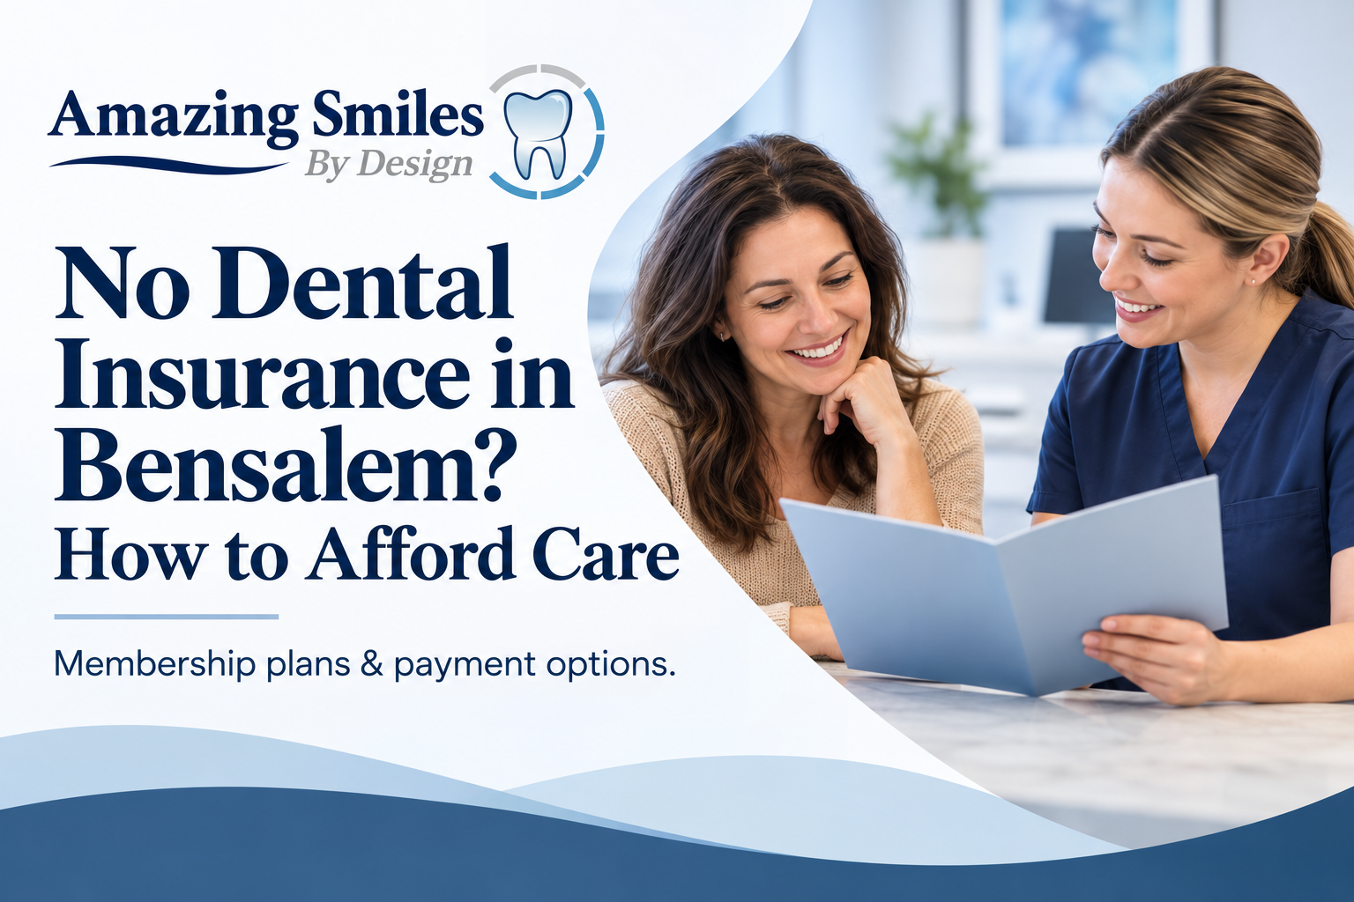
No Dental Insurance in Bensalem? How to Afford Care
Dr. Keyur Dudhat, DMD, Amazing Smiles By Design · Published 6 October 2026 · Updated 6 October 2026
QUICK ANSWER
If you don't have dental insurance, you can still afford care in Bensalem. A yearly membership plan covers your cleanings, exams and X-rays for a flat fee and gives 20% off most other treatment. New patients can get a $59 emergency visit, and CareCredit and Cherry spread larger costs into monthly payments. At Amazing Smiles By Design in Bensalem, you don't need insurance to be seen.

Key Takeaways
- You don't need dental insurance to get care, or to be seen.
- A membership plan covers your routine visits for one flat yearly fee.
- Members get 20% off most other treatments (dental implants and Invisalign are excluded).
- New patients can get a $59 emergency visit with the exam and X-rays.
- CareCredit and Cherry spread bigger treatments into monthly payments.

How Can I Afford the Dentist Without Insurance?
You have three straightforward options, and you can combine them. A yearly membership plan covers your routine care for a flat fee. Financing through CareCredit or Cherry spreads larger treatments into monthly payments. And if you're in pain, a $59 new-patient emergency visit gets you seen without a plan at all. None of these needs insurance. Here's how each one works at Amazing Smiles By Design in Bensalem. Whatever you choose, you'll see the cost in writing before anything goes ahead, and we never push a plan you don't need.

Is a Dental Membership Plan Worth It?
For most people without insurance, yes. A membership plan is not insurance; it's a yearly plan you buy directly from the practice. You pay one flat fee, and it covers the routine visits that keep your teeth healthy, plus a discount on other work. There are no deductibles, no claims and no annual maximum that runs out. If cost has you skipping cleanings, the Regular plan covers two cleanings, two exams and your routine X-rays for $269 a year, the visits that catch small problems before they turn into big bills.

What Our Membership Plans Include
Our plans run for a year and cover your preventive care. See the full details on our specials page.
Plan | Yearly price | What's included
Regular | $269 | 2 professional cleanings, 2 checkup exams, routine X-rays, 1 emergency exam
Perio Maintenance | $450 | 4 periodontal maintenance visits, 2 exams and screenings, routine X-rays, 1 emergency exam
Child (13 and younger) | $212 | 2 cleanings, 2 exams, 2 fluoride treatments, routine X-rays, 1 emergency exam

All members also get 20% off most other dental treatments, with dental implants and Invisalign the two exceptions. We tell you that up front so there are no surprises.
Not sure which plan fits? Ask us and we'll explain the options before you commit, with no pressure to join.
▸ Ask About a Membership Plan (/patient-information/scheduling/)
Or call or text (215) 639-5331.

What About One-Off or Bigger Treatments?
If you need a filling, a crown or other work, there are two ways to keep it affordable:
- Membership discount: members take 20% off most treatments (not implants or Invisalign).
- Financing: CareCredit and Cherry let you spread the cost into monthly payments, with no need for insurance. See financing options.
For a larger plan of treatment, we'll give you the cost in writing first, and show how the discount and financing bring down what you pay each month.

In Pain and No Insurance?
You can still be seen. New patients can book a $59 emergency visit that includes the exam and the necessary X-rays, so you get a diagnosis and a plan without a membership or insurance. If treatment is needed, we'll explain the cost and your options before anything goes ahead. See emergency dentistry.
▸ Ask About a Membership Plan (/patient-information/scheduling/)
Or call or text (215) 639-5331. We're happy to explain the options before you commit.

Membership Plan vs Dental Insurance: Which Is Better?
It depends on how you'd get insurance. If you have good dental benefits through an employer, use them; we accept PPO insurance. If you'd be buying an individual plan yourself, a membership plan is often simpler and better value. Individual dental insurance usually comes with waiting periods, yearly caps and monthly premiums that can add up to more than you claim back. A membership plan has none of those. You pay once a year and use it straight away. Dr. Keyur Dudhat will talk you through both honestly, and never push a plan you don't need. See insurance and payment options.

Care You Can Trust in Bensalem
Not having insurance shouldn't mean putting off the dentist until something hurts. At Amazing Smiles By Design, Dr. Keyur Dudhat and the team look after patients from across Bensalem and the surrounding Bucks County area, with or without a plan. If you're weighing up the cost, tell us your situation and we'll lay out the most affordable way to get the care you actually need, whether that's joining a membership plan, using financing, or simply booking a checkup. You'll always know the cost before you agree to anything, and we won't push treatment or a plan you don't need. The office is at 3101 Bristol Road, Suite 1, and you can call or text (215) 639-5331 any time during office hours.
IMAGE PLACEHOLDER — leave blank; practice-supplied photo.
Developer / designer: optional in-body image slot, left blank for a practice-supplied photo of the Bensalem office or front desk. No stock or AI imagery. WebP, lazy-loaded, width/height set.

No-Insurance Dentist FAQs

Can I see a dentist without insurance?
Yes. You do not need dental insurance to be seen at Amazing Smiles By Design in Bensalem. You can join a yearly membership plan for your routine care, use CareCredit or Cherry financing for larger treatment, or, as a new patient in pain, book a $59 emergency visit that includes the exam and X-rays.

Is a dental membership plan worth it?
For most people without insurance, yes. You pay one flat yearly fee that covers your cleanings, exams and X-rays, with 20% off most other treatment and no deductibles, claims or annual maximum. If cost would otherwise make you skip checkups, a plan usually pays for itself in preventive visits alone.

How much is the membership plan?
Our yearly plans are $269 for the Regular plan, $450 for the Perio Maintenance plan, and $212 for the Child plan for ages 13 and younger. Each covers your routine preventive visits (cleanings, or periodontal maintenance on the Perio plan), exams and X-rays, plus an emergency exam, and all members get 20% off most other treatments.

What does the membership discount not cover?
The 20% member discount applies to most treatments, but dental implants and Invisalign are the two exceptions. For those, CareCredit and Cherry financing are the way to spread the cost. We always tell you up front which treatments the discount does and doesn't cover.

Can I pay for dental treatment monthly?
Yes. CareCredit and Cherry let you spread larger treatments into monthly payments, with no insurance needed. You can use financing on its own or alongside a membership plan, and we'll put the full cost in writing before any treatment starts.

Ask Us About a Membership Plan in Bensalem
No insurance? No problem. Call or text (215) 639-5331, or book a visit with Dr. Dudhat at Amazing Smiles By Design, 3101 Bristol Road, Suite 1, Bensalem, PA 19020, and we'll walk you through the most affordable way to get the care you need.
▸ Ask About a Membership Plan (/patient-information/scheduling/)
▸ Call or Text (215) 639-5331 (tel:+12156395331)

For the editor
SEO title: No Dental Insurance in Bensalem? How to Afford Care (51 chars)
Meta description: No dental insurance near Bensalem, PA? Membership plans, a $59 new-patient emergency visit and financing that make the dentist affordable. Here's how. (150 chars)

Cover image brief (generate in GPT / your image tool)
- A welcoming Bensalem dental front desk with a friendly receptionist helping a patient, bright and calm
- A happy family (adult and child) leaving a dental office smiling
- A simple, clean graphic-free photo of a membership welcome card on a desk
Export the final banner as WebP, 1600×600, and give it descriptive alt text when you place it.

